SEND Policy

This policy will be continuously monitored, refined and audited by the Headteacher who will also review it annually to assess how efficiently duties have been carried out over the year. This review will take place no later than one year from the date shown below, or sooner if needed due to changes in legislation, regulatory requirements or best practice guidelines.

Name of Nursery’s SENDCO is:

Aliya Chaudhri – manager@wovennursery.com

Alice Sinclair – SENDCO@wovennursery.co.uk

Statement of intent:

At Woven Nursery, we welcome children with special educational needs. We believe that every child is equal and entitled to a nursery education that:

Ensures children are treated fairly

Helps every child achieve the best possible early years educational and other outcomes.

Has a designated/appointed SENDCO to support the team, parent/carers and children and to ensure that confidentiality is always met.

Works with parents/carers, teachers and children to make them confident young children with a growing ability to communicate their own views and ready for the transition into compulsory education

Policy aim:

We aim to offer a broad and balanced curriculum with as much access to the EYFS and different pedagogical approaches and philosophies as possible. We ensure that all children with SEND are fully included and engage in all and diverse activities and learning experiences. We ensure that our team members receive the relevant training to enable them to deliver inclusive and differentiated practices.

Key points:

We identify the specific needs of children with special educational needs at the earliest opportunity and meet these through a range of SEND strategies.

We ensure that team members, resources and interventions are planned and allocated according to the needs of the children.

We effectively communicate with parents/carers and other agencies in meeting individual children’s needs.

We make reasonable adjustments to ensure that children with additional needs can access the Early Years Foundation Stage to their full potential.

We offer opportunities for children to experience appropriate high-quality play experiences that encourage curiosity and a desire to know more.

We will take a positive approach, building on children’s strengths and considering their wishes in the light of their age and understanding.

We will involve parents/carers by working in partnership with them, recognising and acknowledging their knowledge and expertise to ensure roles and responsibilities are explicit regarding the Code of Practice 2015

Staff are trained in the LA’s Graduated Response training to identify SEND needs

Roles and responsibilities:

Manager/SENDCO:

Ensuring best practice and meeting the needs of the children, enabling early identification and to facilitate interventions.

Audits, planning and implementation of ITP’s and IEP’s and ensuring that team members and SENDCO have knowledge and understanding of EHCP.

Ensuring that the SEND register is kept for children and is completed regularly with actions taken, tasks reviewed and is audited termly.

Ensuring a team member training log and register is kept in the SEND file and updated by the SENDCO as and when courses are attended.

Liaising with primary schools and their SENDCOs to bridge the gaps during transitions.

Key person:

The nursery operates a Key Person system to best meet the needs of individual children.

Ensuring that each team member is close to and responsible for a small group of children at each session.

Ensuring that planning is based on a differentiated approach to meet the needs of each child.

Recording observations and assessments appropriately for the SEND file.

Parents/Carers:
- Keeping open communication, disclosing any prior diagnosis.
- Keeping the nursery up to date with any progress checks and any other needs.

Educational provision for special needs:

The SENDCO is responsible for the day-to-day management of the SEND policy. They work in conjunction with the Manager and the nursery team members.

The SENDCO ensures and is responsible for and not specific to:
- Liaising between parents/carers and other professionals for children with SEND and taking the lead and supporting the staff in assessing the areas of development in children.
- Ensuring all team members in the nursery understand their responsibilities to children with SEND and how the nursery identifies and meets children with SEND via, for example, observations and assessments.
- Ensuring Individual Education Plans (IEPs) or the individual targeted plans (ITP’s) are up to date and in place.
- Ensuing information about SEND children is collected, recorded and updated.
- Keeping parents/carers informed of the action taken to help the child and the outcome of the action.
- Monitoring and reviewing any action taken.
- Applying for EHC Plans and Contingency funding.
- Attending assessment meetings.
- Liaising with primary schools and their SENDCOs to bridge the gaps during transitions.

Process for identification:
We use the 2015 SEND Code of Practice to identify and assess the special educational needs for the child. These needs could be:
- Communication and interaction
- Cognition and learning
- Social, emotional and mental health
- Sensory/physical needs

SEND support:
Where a child is identified as having SEND, the nursery will take action to remove barriers to learning and put effective special educational provision in place. This SEND support will be a four-part cycle through which earlier decisions and actions are revisited, refined and revised as we develop a growing understanding of the child’s needs and what supports the child in making good progress and securing good outcomes.

This is known as the graduated approach. These four parts are:

Assess – Plan – Do – Review

Assess:
The Key Person will observe individual children’s progress. These observations provide valuable information that will help assess children’s needs and determine what progress has been made.

Children’s progress should be regularly reviewed, and the SENDCO informed of any changes or concerns with individual children. If there is little or no improvement in the child’s progress more specialist assessment may be necessary for specialist teachers, SLT, OT and other agencies.

Plan:
If it is decided that a child requires additional SEND support, then parents/carers will be notified. Their views and wishes will be considered when planning interventions through an IEP or ITP. An IEP (Individual Education Plan) or ITP (Individual Targeted Plan), includes agreed targets, desirable outcomes, relevant interventions and support.

The type of support and interventions applied must be based on reliable evidence of effectiveness and be provided by team members with appropriate skills, knowledge and training. Interventions should be shared with all those that work with the child.

Do:
The Key Person, SENDCO, and other key team members working with the child should implement the interventions within the provision. The parents should then be given guidance on how to implement the same or similar interventions, if they wish to implement them at home.

Review:
Pre-planned reviews should take place regularly and IEP’s/ITP’s updated every six weeks. This will help monitor and assess how effective the support has been and the impact on the child’s progress.

The key person and the SENDCO should work with the parents and any appropriate outside agencies to:
- Revise the cycle of support and intervention considering the review
- Make appropriate adjustments
- Set fresh outcomes

EHCA and EHCP (Education and Health Care Assessment, and Education and Health Care Plan):
For a very few children the help we provide through SEND support and the graduated response (Assess – Plan – Do – Review) will not be enough to enable the child to progress satisfactorily. It will then be necessary for the nursery, in consultation with the parents/carers and any external agencies already involved, to consider how to get the child additional support.

Step 1 - EHCA: An assessment form should be filled in by the nursery SENDCO/Manager in the absence of the SENDCO and will be sent to the relevant panel/board in local boroughs which will then decide whether the child meets the threshold and criterion for having an Educational Health Care Plan and moving to step 2.

Step 2 - EHCP: A request will then be sent back to the nursery who will be asked to complete the EHCP. Once completed, the EHCP will be sent to the relevant SEND support lead.

Resourcing:
In order to best support children with needs, we will ensure that:
- We have a wide and diverse range of toys and equipment in the nursery to meet different learning needs.
- The nursery allocates funds towards the purchase of additional equipment as necessary.
- At least one team member is trained in SEND and will be given sufficient time to fulfil the SEND responsibilities.
- Team member training related to SEND is met through:
- Online training
- Attendance on local authority training courses
- Internal INSET/Training days
- Ongoing CPD

Partnership with parents/carers:
We recognise that parents/carers know their children best and have a vital role to play in their child’s education. We believe parents/carers should be treated as partners, able and empowered to:
- Play an active role in their child’s education by having an opportunity to express their opinions and have their opinions valued.
- Have their child’s difficulties identified early with appropriate intervention to meet those needs.
- Have a real say in how their child is educated by being consulted on IEP targets and being fully informed of their child’s progress.
- Have access to information, advice and support during their child’s assessment and any related decision-making process about intervention and support.
- Have their child’s strengths recognised as well as any additional need.

In order to communicate most effectively with parents/carers, we:
- Maintain a positive and supportive attitude to our parents
- Offer an ‘open door’ policy and a flexible approach to meeting the needs of the parent/carer with a combination of informal chats and formal discussions as appropriate
- Ensure the SEND policy is available to all parents
- Make any outside agency information that may help them and their child easily available
- Inform parents/carers of all stages of intervention.

Legislative Framework:
Special Education Needs and Disability Code of Practice (2015 / Updated 2020)
Equalities Policy and the Equality Act of 2010 Mental Capacity Act 2005

Further reading: SEND Code of Practice (2014) – GOV.UK https://www.gov.uk/government/publications/ send-code-of-practice-0-to-25 Updated (2020)

SEND: old issues, new issues, next steps – GOV.UK (www.gov.uk) The Special Educational Needs and Disability Regulations 2014

Appendix:

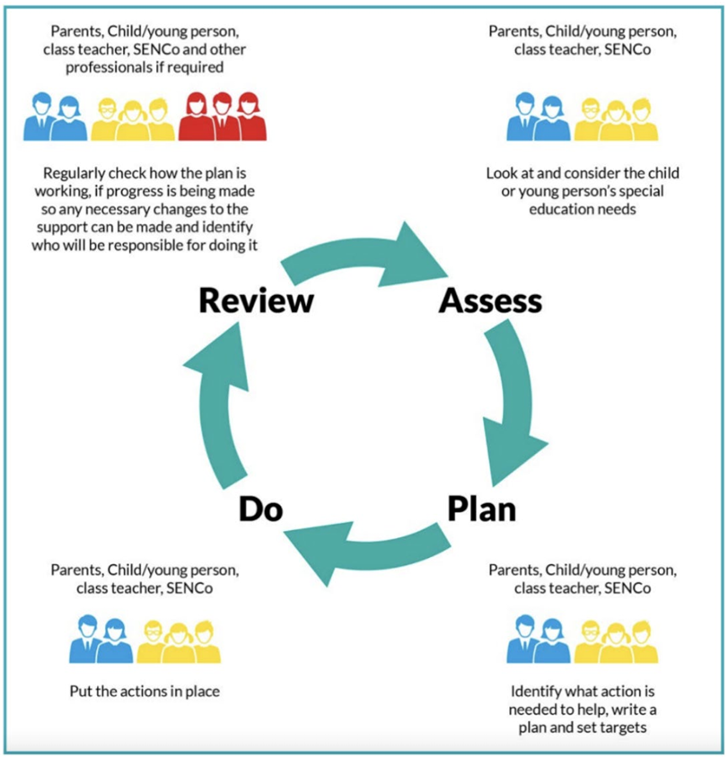

This policy was adopted on | Signed on behalf of the nursery | Date for review
22nd December 2025 | Aliya Chaudhri | 22nd December 2026

