Mealtime Policy

This policy will be continuously monitored, refined and audited by the Headteacher who will also review it annually to assess how efficiently duties have been carried out over the year. This review will take place no later than one year from the date shown below, or sooner if needed due to changes in legislation, regulatory requirements or best practice guidelines.

Statement of intent:

At Woven Nursery, we believe that mealtimes should be happy, social occasions for children and team members. We promote shared, positive interactions at these times. We are committed to offering children healthy, nutritious snacks that meet individual needs and requirements.

Policy aims:

This policy is in place to inform parents/carers and team members about nutrition and mealtimes at nurseries. It is intended to help identify and cater for individual food requirements and to promote healthy eating in a relaxed atmosphere.

We understand that early food experiences have an important effect on adult eating patterns and may influence attitudes to eating, so Woven is committed to providing food that supports the development of healthy eating practices now and in the future.

Key points:

We organise meal and snack times so that they are shared social occasions between team members and the children.

We use meal and snack times to help children develop independence through making choices, serving food and drink and feeding themselves.

We provide children with utensils/cutlery that are appropriate for their ages and stage of development considering each child’s cultural eating practice.

We ensure children always have access to fresh drinking water.

We regularly consult with parents/carers to ensure that our records of their children’s dietary needs, including any allergies, are up to date.

We implement systems to ensure that children receive only food and drink that is consistent with their dietary needs and their parents’/carers’ wishes.

We work with a reputable meal provider – Educatering Solutions HOME | Educatering Solutions, involving local authority guidelines where possible.

Team members will keep the mealtimes routine as close to the home environment as possible which includes washing hands and eating with the children for positive role modelling, as we do not advocate the use of plastic gloves and aprons.

We provide nutritious food at all meals and snacks, avoiding large quantities of fat, sugar and salt and artificial additives, preservatives, and colourings.

Staff are trained in Pediatric First Aid, Food and Hygiene, Awareness course and other relevant training.

Staff sit with children at meal times.

Approach to Nutrition:

We champion a balanced and healthy diet for all the children.

For those children attending a standard day at the nursery (08:30-16:00) we will provide breakfast, lunch and a snack.

For those children attending a full day including wraparound at the nursery we will provide breakfast, lunch, snack and tea.

Menus are planned by Educatering Solutions in line with recommended nutritional guidelines, rotated regularly and reflect cultural diversity and variation. They are also displayed for children and parents/carers to see (Autumn/Winter, Spring and Summer menus).

NURSERY PARENTS | Educatering Solutions

We provide nutritious food at all snack times, avoiding large quantities of fat, sugar, salt and artificial additives, preservatives and colourings.

Team members will always support children in making healthy choices and help them to understand the need for healthy eating. They will encourage the children to eat all portions of their meals with a strong emphasis on fruits and vegetables.

We aim to offer and celebrate food from all our children’s cultural backgrounds (in accordance to Educatering Solutions Menus), providing children with familiar foods and introducing and encouraging them to try new ones.

Approach to eating:

We use meal and snack times to help children to develop independence through making choices, serving food and drink, and feeding themselves. The children may be given the responsibility of laying out the table in turns and adults can support the routine by placing the plates, cups and cutlery on the tables to assist with smooth transition of the mealtimes.

We provide children with utensils/cutlery which are appropriate for their ages and stage of development and considering the eating practices in their cultures.

Fresh drinking water and milk is always available and accessible. It is frequently offered to children and intake is monitored. In hot weather, team members will encourage children to drink more water to keep themselves hydrated.

We encourage children to prepare their own snacks and take active part in cutting the fruits and vegetables with the supervision of team members who will role model the cutting and will encourage independence. In this way we promote our ethos of children taking the lead in their own learning.

Staff sit with children during meal times to set a good example and eat with the children modelling good table manners.

Meal and snack times are organised so that they are social occasions that children and team members take part in together in small groups.

During meals and snack times children are encouraged to use their manners and to say ‘please’ and ‘thank you’ and conversation is encouraged.

Any child who shows signs of distress at being faced with a meal they do not like will have that food removed/moved to one end of the plate by a teacher or supported to move it themselves.

We will always respect cultural differences in eating habits. If a child did not eat at a set

mealtime and is seen to be hungry, then we will offer a healthy, suitable snack before the

next meal is offered.

Children are given time to eat at their own pace and will not be rushed.

Quantities offered take account of the ages of the children being catered for in line with recommended portion sizes for young children. Consideration is paid towards how to cut fruits and vegetables to prevent choking (see appendix A).

Infants and young children will be seated safely in a highchair or an appropriately sized low chair while eating.

Children will never be left alone while they are eating, and team members will be familiar with Paediatric First Aid advice for children who may choke.

Approach to hygiene at Mealtimes:

Staff will wash their hands before serving the meal and will support all children in washing their hands before each meal. We do not use plastic gloves and aprons because we want to keep the serving routine like a home environment. This also reflects our approach to environmental awareness.

After each meal and snack, the children will be supported to wash their hands and faces if needed – this may be with reusable clean flannels.

Managing dietary requirements and allergies:

Our nursery is a nut free environment.

All food given to children in the nursery comes through our agreed supplier, and parents cannot bring in food.

Following our mandatory training programme All staff are trained in the signs, symptoms and how to respond to a possible allergic reaction in the case of an unknown or first reaction in a child. These may include a rash or hives, nausea, stomach pain, diarrhoea, itchy skin, watery eyes, shortness of breath, chest pain, swelling of the mouth or tongue, swelling to the airways or the lungs, wheezing and anaphylaxis.

Where staff wish to bring in their own food this must be kept out of the rooms and placed on the designated shelf in the fridge, food must be nut-free, compliant with any specific allergy rules for the nursery and it is the staff member’s responsibility to store hygienically and appropriately. Staff are not to share any food that they bring in with any children in the setting.

We ask parents/carers to share all information about allergic reactions and allergies on their child’s registration form and to inform team members of any allergies discovered after registration. We share all information with all team members.

Individual dietary requirements are respected. We gather information from parents/carers about their children’s dietary needs, including any special dietary requirements, preferences, and food allergies that a child has and any special health requirements before a child starts or joins the nursery.

Where a child has a known medically diagnosed allergy, the Manager will carry out a Risk Assessment with the parent/carer prior to the child starting the nursery and/or following notification of a known allergy. This assessment will shared with all staff.

Parents will be required to provide two EpiPens for their child if they are prone to any anaphylactic shock and is prescribed by a doctor. Parents must check that their child’s EpiPen does not expire. The nursery is not required under current legislation to hold any spare EpiPen.

Food is provided by an external catering company, members of staff will be nominated each day to receive the delivery check allergen information visible on the labels or stickers and ensure that food arrives to the room for any children with allergies clearly labelled. This will be checked by the lead practitioner in the room on receipt

Any dietary requirements will be identified when children are at the table by using a colour code system, usually with plates – children will be informed of their plates so they are aware of their allergies where appropriate and those who are not will be given their food on the correct coloured plates

The system at Woven is:

Colour RED Allergen - Allergy is noted on wall

Colour GREEN - Vegetarian

Colour BLUE/WHITE (dependent on age) – able to eat all

We consider seating arrangements to avoid cross contamination of food from child to child and where appropriate, an adult will sit with children during meals to ensure safety and to minimise risks.

If a child has an allergic reaction to food, a bee or wasp sting, a plant etc. a paediatric first aid trained team member will act quickly and administer the appropriate treatment, where necessary. Parents/carers must be informed, and the information recorded in our accident/illness book.

If an allergic reaction requires specialist treatment, e.g. an EpiPen, then at least two team members working directly with the child and the Manager will receive specific medical training to be able to administer the treatment to each individual child.

In the event of a serious allergic reaction and a child needing transporting to hospital, the Manager/team member will follow the emergency procedures laid out in our Accident and Incident Policy.

Food Preparation:

All team members who prepare and handle food are competent to do so and receive training in Food Hygiene - minimum Level 2 for all team members, updated every three years.

Our food preparation areas follow EHO guidelines around cleaning and maintenance and are inspected annually.

In the very unlikely event of any food poisoning affecting two or more children on the premises, whether or not from food offered at the nursery, we will inform Ofsted as soon as reasonably practical and in all cases within 14 days. We will also inform the relevant health agencies and follow any advice given.

We observe the following food safety preparation advice for children aged 5 and under, to reduce the risk of choking:

Remove any stones and pips from fruit before serving.

Cut small round foods, like grapes, strawberries, and cherry tomatoes, lengthways and into quarters.

Cut large fruits like melon, and hard fruit or vegetables like raw apple and carrot, into slices instead of small chunks.

Do not give whole seeds to children under five years old.

Cut cheese into strips rather than chunks.

Do not give popcorn as a snack unless supervised in small groups as part of a Nursery activity.

Do not give children marshmallows or jelly cubes from a packet unsupervised as part of messy play activities as they can get stuck in the throat.

Do not give children hard sweets

Legislative Framework:

EYFS 2024

Keeping Children Safe in Education 2024

Early Years Policies September 2024 - Version 1 73

Mealtimes Policy – Appendix:

The Eatwell plate:

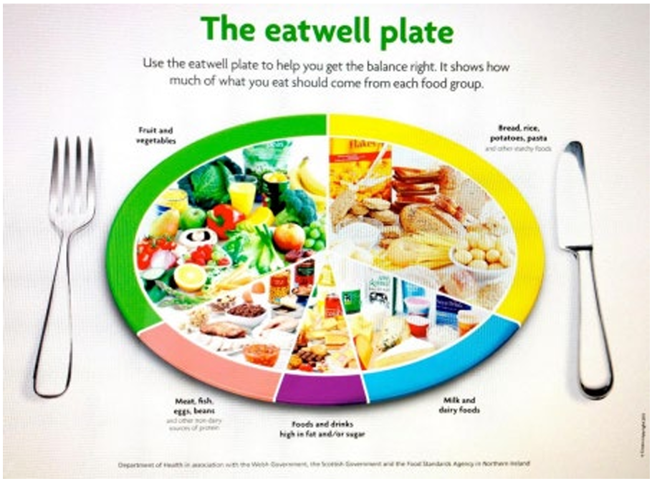

Appropriate food preparation:

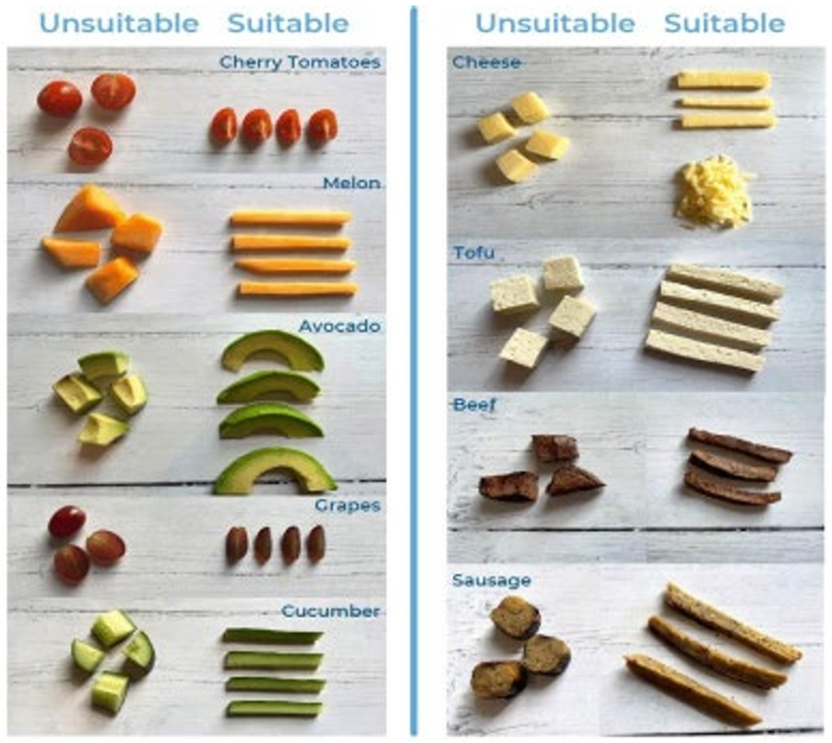

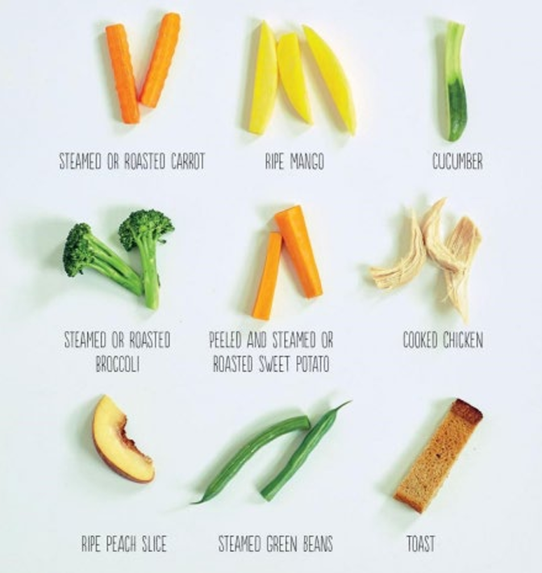

Portion sizes:

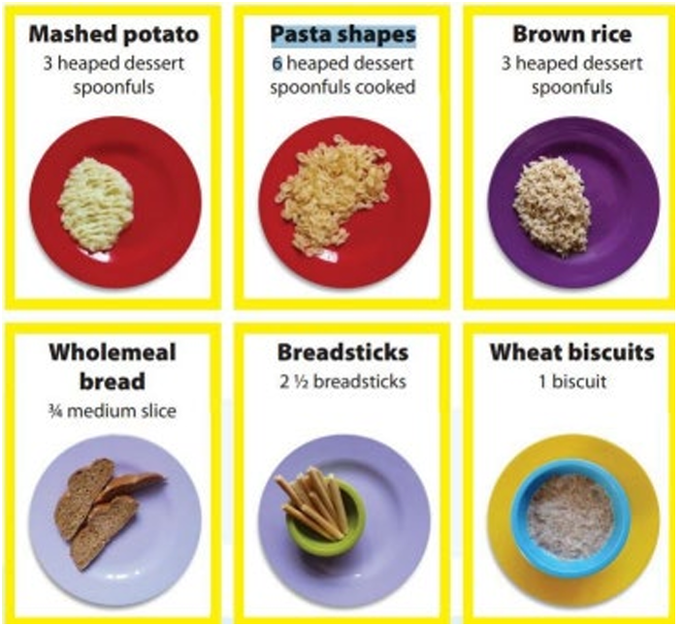

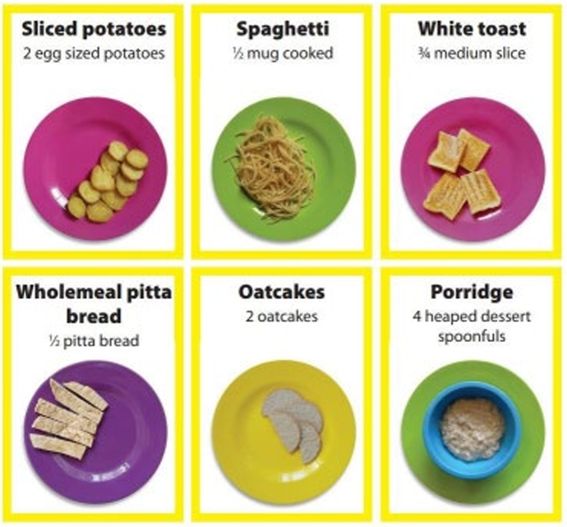

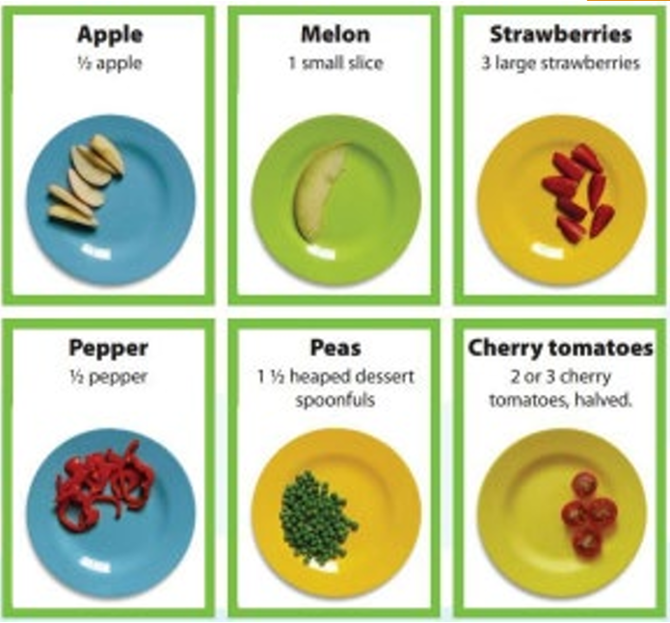
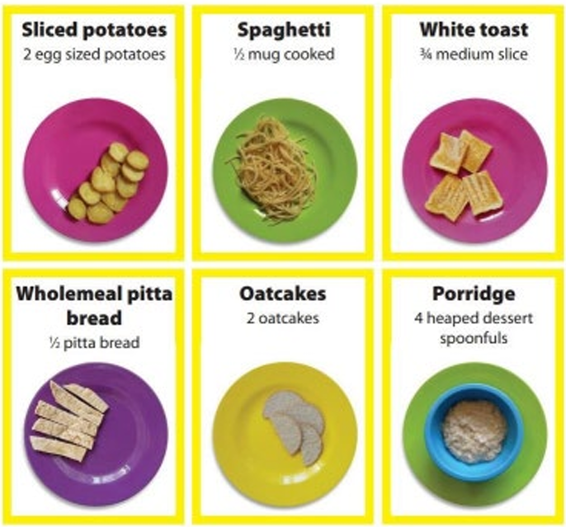

This policy was adopted on | Signed on behalf of the nursery | Date for review
22nd December 2025 | Aliya Chaudhri | 22nd December 2026

